* **Domain Name of Website:**

<http://easyshop.liveblog365.com/>

* **Ecommerce Website:**

**Introducing easyshop :** A Ecommerce Website

The primary objective of easyshop is to create an online platform that offers a convenient and seamless shopping experience for customers. The project aims to achieve the following goals:

* Provide a user-friendly interface: Develop an intuitive and easy-to-navigate website interface that enhances the overall shopping experience for users.
* Curate a diverse product range: Offer a wide variety of products across different categories to cater to the diverse needs and preferences of our customers.
* Ensure secure and efficient transactions: Implement robust security measures and reliable payment gateways to ensure safe and hassle-free transactions.
* **Theme: Woostify**

by Woostify

* Woostify is a powerful and feature-rich WordPress theme designed specifically for WooCommerce-based online stores. With its versatile and customizable nature, Woostify offers a seamless and user-friendly experience for both website owners and customers.
* Woostify is built with a mobile-first approach, is lightweight and fast, and offers customization options to create a unique and visually stunning online store. It is optimized for speed and efficiency.
* Woostify is a dedicated WooCommerce theme that integrates with the popular eCommerce plugin, providing a comprehensive and feature-rich platform for selling products online. It offers advanced product display options, SEO-friendly features, and extensive documentation and support. The theme is designed with SEO best practices in mind, allowing users to optimize meta tags, headings, and other important elements to improve their website's visibility and rankings.



* **Plugins Used in my Website:**

1. **WooCommerce­­­­ :-**

* The WooCommerce plugin for WordPress is a powerful and widely used solution for creating and managing online stores. It provides a comprehensive set of features and tools to help you sell products or services effectively, manage inventory, process payments, and enhance the overall shopping experience for your customers.
* It integrates with WordPress, allowing users to create an online store with just a few clicks. The setup wizard guides users through the configuration process.
* WooCommerce offers flexible options to categorize, set prices, manage inventory, and define product variations, as well as product images, descriptions, and specifications.
* WooCommerce supports a variety of payment gateways to securely process payments from various sources and currencies, giving customers peace of mind.
* It simplifies shipping and tax calculations by allowing users to set up multiple shipping methods, define shipping zones, calculate shipping costs, and configure tax settings.
* WooCommerce offers a variety of extensions and plugins to customize and enhance the functionality of an online store to meet specific needs.
* WooCommerce provides data-driven reports to help store owners understand their strengths and identify areas for improvement, allowing them to make informed business decisions.
* WooCommerce is mobile-responsive and offers customization options to tailor the appearance and layout of your store to match your brand identity and preferences.
* WooCommerce is a popular eCommerce solution with a supportive community and dedicated customer support to help users set up and manage their online store.
* WooCommerce is a powerful plugin that helps you create and manage an online store with WordPress, allowing you to showcase and sell products effectively while providing an exceptional shopping experience for customers.

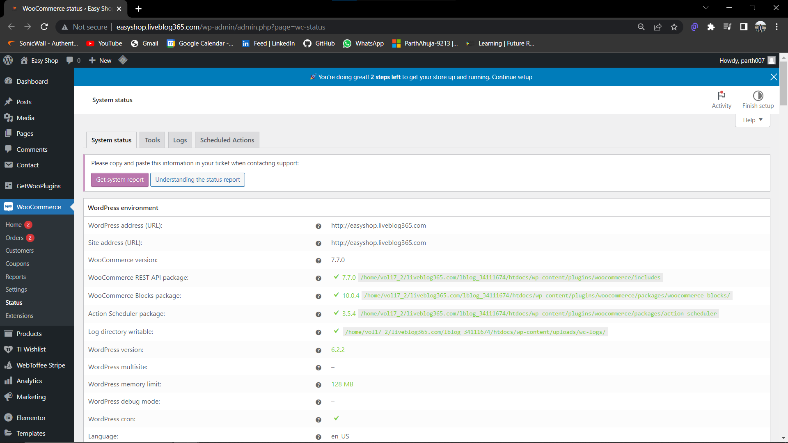

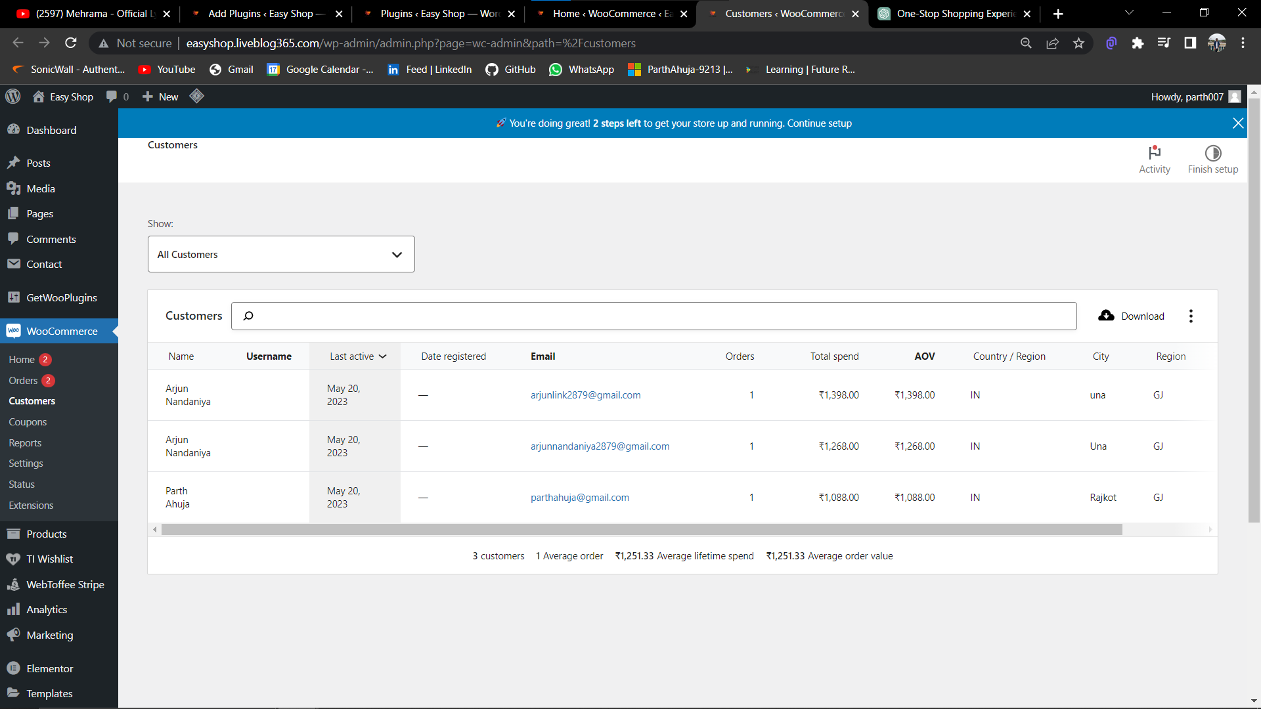

1. **Elementor (Server side)**

* Elementor is a popular WordPress plugin that allows you to design and build professional-looking websites without any coding knowledge. It provides a drag-and-drop interface and a wide range of pre-designed templates and widgets, making it easy for users of all skill levels to create stunning and responsive websites.
* Elementor is a front-end visual editor that allows users to easily add elements, rearrange sections, and customize the layout of their pages without switching between editing modes.
* Elementor offers a variety of professionally designed templates for various website niches and purposes, which can be customized to match branding and content.
* Elementor provides a library of widgets that can be customized and styled to fit your website's design and functionality requirements.
* Elementor allows you to create responsive websites that look great on all devices by controlling the appearance and behaviour of elements. You can hide or show sections, adjust column widths, and set custom spacing and alignment.
* Elementor enables advanced users to apply custom CSS code to any element, allowing for unlimited customization possibilities to create a unique website.
* Elementor integrates with WordPress and popular WordPress plugins, allowing for the integration of contact forms, social media buttons, eCommerce functionality, and more.
* Elementor is a flexible platform for customization, offering hooks, filters, an API, and a template builder to create custom templates and widgets.

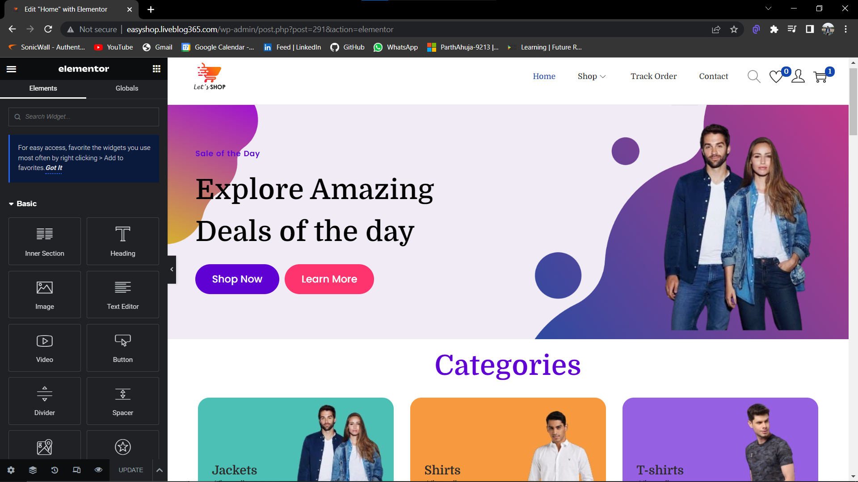

1. **Stripe Payment Plugin for WooCommerce:**

* The Stripe Payment Plugin seamlessly integrates with WooCommerce, making it easy to set up and configure. Once installed and activated, you can quickly connect your Stripe account to your online store and start accepting payments.
* The Stripe Payment Plugin makes it easy to connect Stripe accounts to WooCommerce and accept payments.
* Stripe supports a variety of payment methods, allowing businesses to offer customers a variety of options to suit their preferences.
* Stripe's secure infrastructure ensures your store is PCI DSS compliant, eliminating the need to handle sensitive card data.
* Stripe Payment Plugin automatically updates WooCommerce order status when a customer completes a successful payment, saving time and effort.
* Stripe Payment Plugin supports recurring payments and integrates with WooCommerce Subscriptions to manage subscription plans, billing cycles, and automatic renewals.

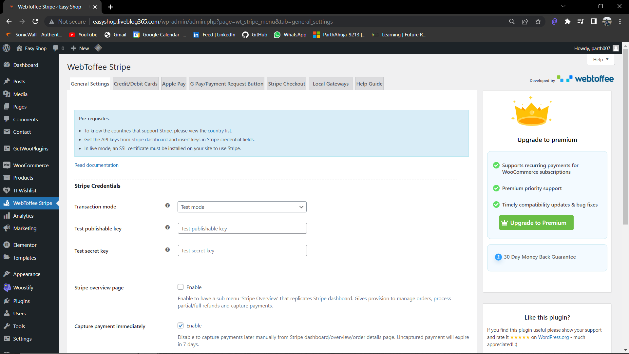

1. **Razorpay for WooCommerce:**

* Razorpay for WooCommerce is a payment gateway integration that enables you to accept online payments on your WooCommerce store using the Razorpay platform. Razorpay is a popular payment gateway provider in India, offering a wide range of payment options and features for businesses.
* Razorpay is designed to cater to Indian merchants and customers, supporting popular payment methods such as credit and debit cards, net banking, UPI, wallets, and more.
* Razorpay for WooCommerce is easy to install and configure, providing clear instructions and settings to ensure a smooth setup process.
* Razorpay allows businesses to accept payments in multiple currencies, allowing for a hassle-free payment experience.
* Razorpay provides a secure payment environment by implementing SSL encryption and two-factor authentication to protect customer data.
* Razorpay automatically updates the order status in WooCommerce store when a customer completes a payment, allowing for easy tracking and management.
* Razorpay provides a dashboard to track business performance, analyze trends, and make informed decisions.

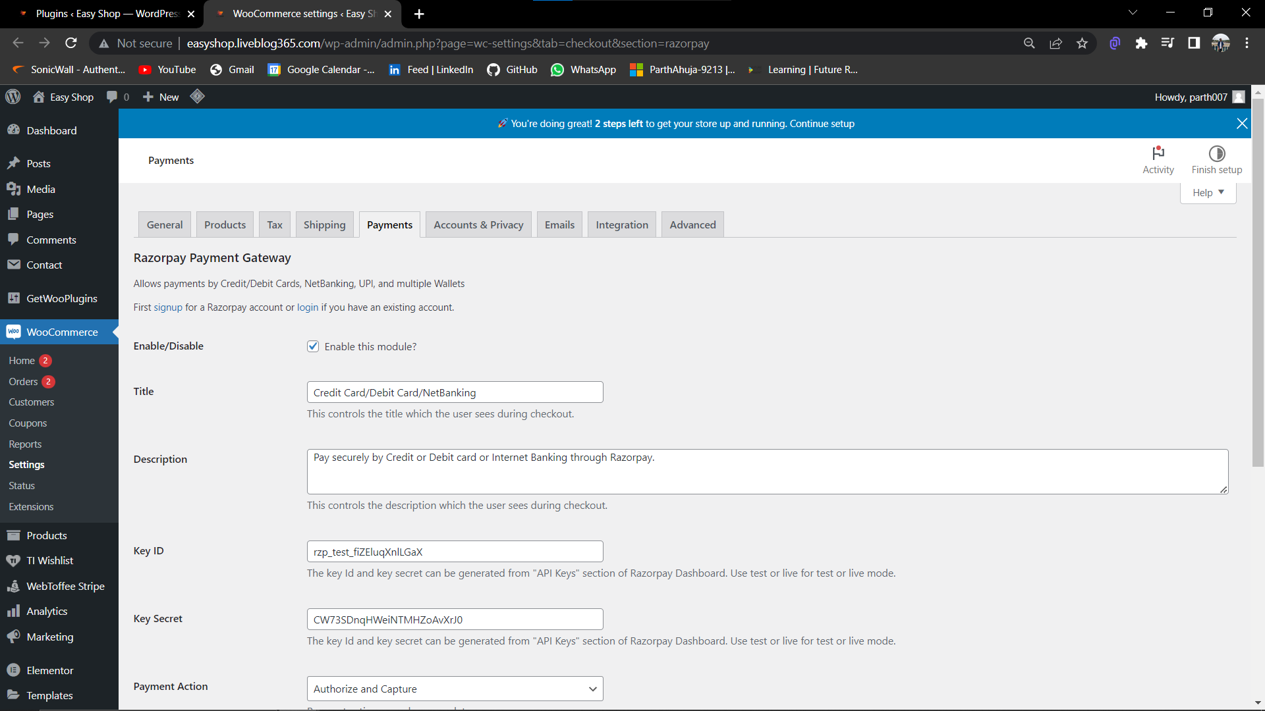

1. **Forminator:**

* Forminator is a powerful and user-friendly WordPress plugin that allows you to create and manage forms on your website. It provides a comprehensive set of features to design, customize, and integrate forms. Forminator offers a drag-and-drop form builder interface to create forms without coding knowledge, with a variety of form fields to choose from.
* Forminator provides pre-built form templates for various use cases, which can be customized to match your website's design and requirements.
* Forminator provides extensive customization options to tailor forms to your needs, including custom CSS classes and styles to individual form elements.
* Forminator uses conditional logic to create interactive and personalized forms that adapt to the user's input.
* Forminator enables users to create multi-step forms, reducing long forms into manageable steps and improving form completion rates.
* Forminator allows users to manage form submissions and data within their WordPress dashboard, export, analyse, and send email notifications. It also supports Google reCAPTCHA and Honeypot techniques to ensure genuine submissions are accepted.
* Forminator integrates with third-party services and plugins to extend its functionality and enhance forms, such as email marketing, payment gateways, CRM systems.

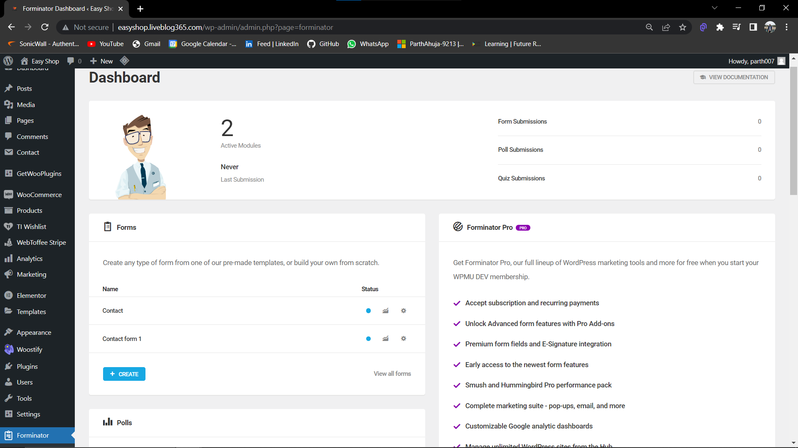

1. **Classic Widgets:**

* The Classic Widgets plugin for WordPress is a tool that brings back the traditional widget management system in WordPress. It allows you to use and manage widgets in the familiar way prior to the introduction of the block editor in WordPress version 5.8.
* The Classic Widgets plugin brings back the classic interface, allowing users to manage widgets using drag-and-drop.
* The Classic Widgets plugin provides a smooth transition from the old widget system to WordPress, preserving the workflow and functionality you are used to.
* Classic Widgets ensures that all widgets used before the block editor are still available and functional.
* The Classic Widgets plugin allows you to create, edit, and arrange widget areas on your website, allowing you to control the visibility and placement of widgets.
* The Classic Widgets plugin ensures that widgets will work with any theme and other plugins on your site. The Classic Widgets plugin is actively maintained and supported by its developers, providing regular updates, bug fixes, and compatibility improvements.

